Study of effects appearing in the high velocity liquid flows through the tube

Miliya Arkad’evich Margulis, Nikolay Nikolaevich Kuznetsov, Evgeniya Evgenievna Goncharenko

Bauman Moscow State Technical University, 2-ya Baumanskaya street, 5, Moscow, 105005, Russia

Abstract. A considerable potential difference (about 1000 V) emerging in dielectric liquid from the metallic electrodes arranged along its flow through a 6mm tube in diameter has been revealed. The effect is referred to as hydrodynamic. It follows from ocillograms that an electric signal is of high frequency. It cannot be synchronized. A potential difference between the capillary inlet and outlet is as high as 200 V and 700 V, respectively, for positive and negative pulses. It has been shown that raising the temperature up to 30-35⁰С and the backwater pressure leads to the potential difference decrease. A mechanism based on a predominant role of electro-kinetic phenomena to emerge a potential difference has been developed.
[Margulis M.A., Kuznetsov N.N., Goncharenko E.E. Study of effects appearing in the high velocity liquid flows through the tube. Life Sci J 2014;11(11s):717-721] (ISSN:1097-8135). http://www.lifesciencesite.com. 159

Keywords: cavitation, cavitation bubbles, hydroelectric effect, electric signal, dielectric liquid, liquid electrification, electro-kinetic potential, Poisson equation

Introduction
Ultrasonically induced cavitation was studied in many papers [1-6]. Far less number of them [7-11] concerns the hydrodynamic cavitation. An interest to hydrodynamic cavitation has quickened recently, after A.I. Koldomasov’s publications [4,9], which consider a phenomenon of luminescence appearing in liquid. The papers [10-11] took notice that electric pulses are detected when transformer oil flows through the thin passage orifice of 1 mm in diameter. It was perceived that an electric signal appeared long before the cavitation. The electric signal record was accomplished by insertion of metallic electrodes into the liquid flow. The article shows that luminescence occurs before the washer with the passage orifice while after it where cavitation bubbles may collapse there is no luminescence. Electric discharges appeared even at low rates of liquid flow when it was well known that there was no cavitation. These investigations [10-11] argue against the thermal theories and their modifications associating the light emission with the cavitation bubbles collapse that may occur only under raised pressure in liquid [1,4,7,8].
A hydroelectric effect emerging in liquids, when flowing, is of great research and application importance. Therefore its further research is of interest. In this paper apart from the previous ones potential differences arising along the hydrocarbon flow using two in-series electrodes are measured, and influence of various factors is studied. A mechanism of the process is considered.

Materials and methods
Fig.1 shows an experimental unit diagram. A liquid hydrocarbon with the boiling point below 340⁰С (under atmosphere pressure) was pumped through the tube 1 made from organic glass with the stainless steel electrodes A, C at its both ends. The inner diameter of cylindrical electrodes (6mm) precisely matched to that of the tube. The inter-electrode distance was 55mm. The oscillograph provided continuous records of potential difference between A and C points. In some experiments a metallic grid was set in section B. It should be noted that the potential difference between A and C was equal to zero. The first experiments have already shown that without grid in some seconds under rather low hydrocarbon pressure in the system (5 – 10 atm) there was quite a high potential difference ∆U ≈ 1000 V between the electrodes A and C. This fairly general process is called a hydroelectric effect.

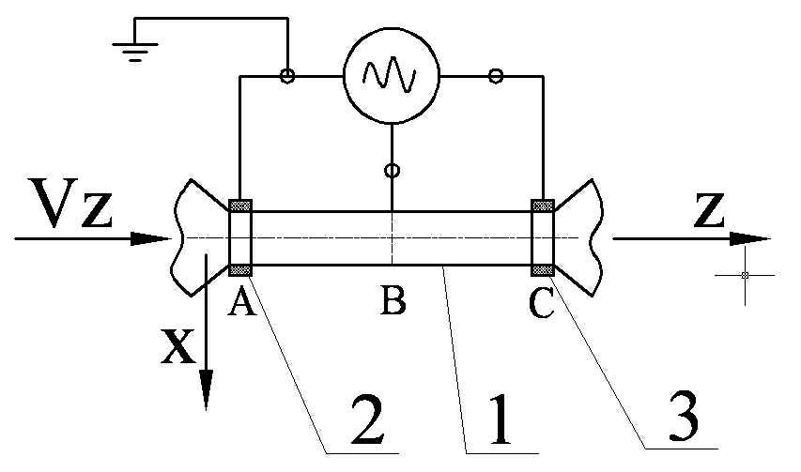

Fig. 1. Experimental unit diagram
1- an organic glass tube; 2 and 3 – stainless steel electrodes

The experimentally obtained potential difference between the terminals А and С turned out to be by 2 – 3 orders higher than that of at one-electrode measurement [10] though in the given paper we studied the liquid flow through the sectional area 36 times exceeding that of in the paper [10].
Hence, in the later experiments a system was developed to enable continuous scanning of changing potential with continuous flow along its axis. Fig.2 shows a typical oscillogram of electric pulses at the two-electrode measurement of potential arising when hydrocarbon flows through the channel of 5mm in diameter under 10atm pressure in the system and backwater pressure of 5 atm. In this case a potential difference ∆U reaches 700V. As it turned out, the electric signal is a train of single pulses both, positive and negative, with the number of positive ones well above that of negative.
However the amplitude of negative pulses is two or three times higher than that of positive ones (Fig. 2). The electric signal recorded in the form of discrete pulses was of high frequency. It could not be synchronised, and some peaks could reach 1000V. A reason of revealed behavior is not clear yet. Note, that a discharge has a negative charge when recording a total difference of potentials.
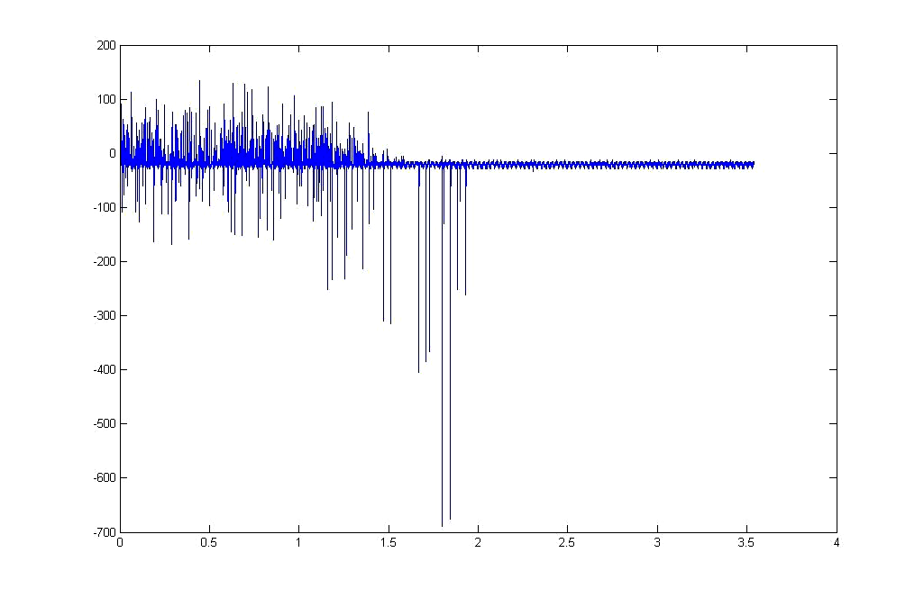
Fig.2. Typical oscillogram of electric pulses

Test experiments have shown that a hydrodynamic cavitation can have an essential influence on the phenomena under observation, intensify them, but it is not required to cause a hydroelectric effect.
The important factor that has influence on the micro-bubbles dimension and behavior in the liquid is a backwater pressure. The experiments have shown that under the backwater pressure of about 5 atm an intensity of electric signals gradually decreases up to zero with the electric pulse form being similar to that of the luminescence at ultrasonic cavitation and sonoluminescence [2,3]. When conducting the experiments, quite a fast rise and rather slow drop of ∆U was observed. The fall time of the single electric pulse intensity was approximately about 30 [micro]s.

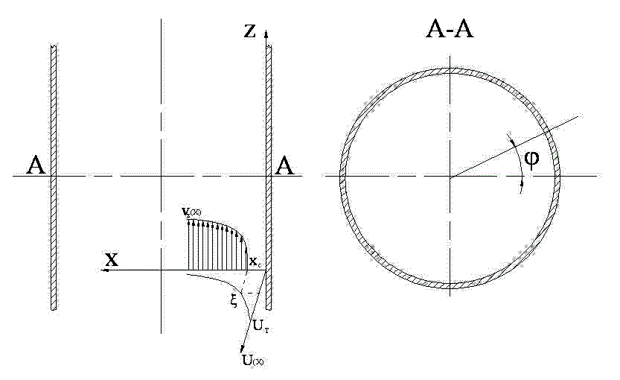
Fig. 3. Double electric layer formation diagram (A-A cross-section)

Results and discussion
The experimental investigations have shown that the hydroelectric effect seems to be related to the emergence of electro-kinetic phenomena and just in part to the action of hydrodynamic cavitation [11]. The electricity transfer in ideally cleaned homogeneous liquids with no gas micro-bubbles is unlikely. Presence of micro-bubbles in liquid influences on many phenomena, for example, leads to appearing a hysteresis during hydrodynamic luminescence [2,10].
In our experiments an electric charge formed inside the tube through which hydrocarbon flows is transferred in liquid by micro-bubbles, and then it can be accumulated on the metallic electrodes, which are connected to the recorder. A local liquid electrification, in our opinion, relates to the double electric layer formed on the interphase surface. The double electric layer is formed on the inner surface of tube through which liquid moves [10,11].
A mathematical model of phenomena under consideration is mostly, similar to the local electrification theory M.A. Margulis, one of the authors [2,12], offered while developing a mechanism of chemical and physicochemical effect of ultrasonic waves [1,2].
Let us consider liquid motion in cylindrical coordinate system. The axis х has a normal direction to the inner surface of tube (Fig.3) liquid wards, the axis z is in direction of liquid motion, and [phi] is an angle of flow direction with respect to the vertical for the throttle. With x < х_{s} (х_{s} is slip boundary), charges can move only together with the liquid surface layer. Just these charges form an uncompensated electric charge on the interphase surface inside the tube after “washing off” a part of diffusion layer. In liquid there is the same uncompensated electric charge of the opposite sign. As a result, a disperse medium and a disperse phase have opposite charges.
Keeping in mind that a value х_{s} << r (r is an inner tube radius), the interphase surface can be treated as a plane one, and the charge density distribution [rho], [rho] in liquid can be to high accuracy described by one-dimensional Poisson equation:
ρ_{el} = -εε₀ (∂²U/∂x²), (1)
where U is an electric potential, [epsilon] is a dielectric permittivity of liquid, [epsilonzero] is a dielectric permittivity of liquid. Thus, a flow rate distribution in Newtonian liquid on the inner surface of tube is described by the formula:
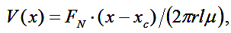
(2)
where F_{N}(x) is a Newtonian force appeared due to viscous liquid layers moving with velocity v(x); l and r are, respectively, a length and a radius of tube cross-section, [mu] is a liquid viscosity. Near the solid surface with x ∼ x_{s}, a liquid flow can be viewed as a laminar one, dv/dx and F_{N} being constant.
The charging current of the interphase surface (electricity amount per unit of time) can be as follows:
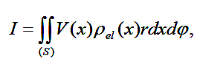 (3)
where (S) is a sectional area of the liquid flow. Considering that ρ_{el} (x) and v (x) are expressed by formulas (1), (2), we obtain the following relation for the charging current of the inner wall of tube [11]:
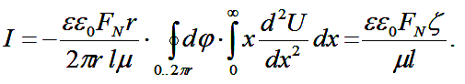
(4)
In the latter transformation an integral between the limits 0 and ∞ is assumed to correspond to electro-kinetic potential [zeta] (it is understood, that in this case the upper limit of integration is an inner tube orifice radius r). For the liquid flow “washing off” diffusion portion of double electric layer the following force balance condition may be written:
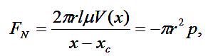where p is a pressure applied to the throttle inlet section. For many systems [zeta]< 0 and, besides, it change the sign. Therefore, for simplicity, we omit signs before the factors πr²p and [zeta]. Thus, a formula for charging current of the wall inside the tube is as follows:
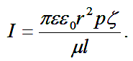 (5)
Taking into consideration that charging and drain of electric charges (due to conduction current i) are simultaneously accomplished we obtain a general equation of uncompensated charge balance:
dQ/dt = I – i (6)
Note that this and subsequent equations do not use cavitation parameters of liquid flow. Therefore, equations may be applied both under precavitation operation conditions and under cavitation ones. An electric potential on the wall inside the tube is equal
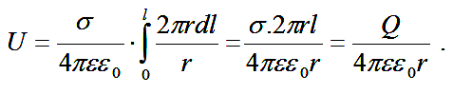 (7)
Electric resistance is described by the formula below
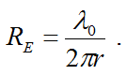
Hence, we obtain formula for the conduction current:
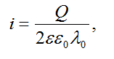 (8)
wherе [lambdazero] is a specific factor of electric resistance of liquid, [sigma] is charge density on the wall inside the tube. Neglecting the flow pulsations and assuming that the liquid flow rate through the tube section is constant (i.e. only a charge Q depends on the time t), we obtain the following equation for the electric charge balance Q (t), which appears when liquid flows through the throttle:
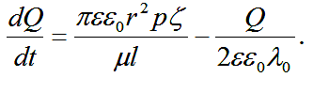 (9)
An integration of equation (9) gives
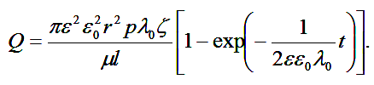 (10)
For the steady-state conditions when t → ∞ and dQ(t)/dt → 0 a solution of equation (10) is as follows:
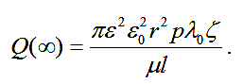
(11)
Equation (11) allows calculation of accumulated electric charge.
Let us calculate a stationary charge accumulated on the inner surface of tube using the values of experimental parameters: r =3.10⁻³ m, l = 5.5.10⁻² m, p = 1 МPа = 10 bar, [lambdazero] = 10⁹ Ohm•m, [zeta] = 1 V, [mu] = 200 Pa•s/m². After substitution of values in the formula (11) we obtain:
Q (∞) = 1,7. 10⁻¹² C
It may be considered that the charge formed on the inner wall of insulating tube is periodically “washed-off” by the hydrocarbon flow containing gas micro-bubbles and is applied to the stainless electrode connected to the oscillograph (Fig. 1). Electrons cannot independently migrate from electrode to electrode across the hydrocarbon flow. The active carriers of charged particles (electrons and ions), in our opinion, can be weighted-in-liquid microscopic gas bubbles. As known, a great number of micro-bubbles (10² – 10⁶ сm⁻³) always exist in real liquid, and they may be removed only by taking special precautions. As soon as a micro-bubble with charges adsorbed on it touches the right electrode, an electric current pulse appears in the close-loop circuit to switch on the first along the liquid path electrode A, the second electrode C, jumpers, oscillograph, and liquid hydrocarbon (Fig.1). The time to discharge the close-loop circuit possessing a charge formed by the bubble can be calculated using the electric resistance of hydrocarbon fragment of length l. Thus, the resistance of stainless electrodes and jumpers can be neglected. By Ohm’s law Q (∞)/ τ = ∆U / R, where [tau] is fall time of accumulating signal on the oscillograph screen. According to results of conducted experiments, a discharge signal average time [tau] is approximately about 3.5.10⁻⁵ s. Taking into consideration that R = λ₀/l, the maximum recorded potential difference between the electrodes ∆U _{max} = Q (∞) λ₀ /(l τ) is consistent with obtained stationary charge accumulating on the wall inside the tube.
Understanding that Q (∞) = 1,7. 10⁻¹² С, the given formula allows us to calculate the amplitude of maximum voltage in the pulse using the experimental parameter, namely ∆U _{max} is approximately about 1000V. It correlates well with the experimentally obtained values: ∆U _{max} is approximately about 700 V (Fig. 2).

Conclusion
Experimental results obtained in the work verify a dependence of the electric charge density on the key parameters:
- with increasing pressure p in the tube from 5 to 40 atm the amplitude of electric charges 8-10 times decreased;
- with decreasing electric resistance of liquid λ₀ from 10¹⁰ to 10⁸ Ohm•m  the amplitude of positive and negative electric pulses 10³ times decreased;
- with decreasing length of 1 passage orifice from 8 to 0.5 mm the amplitude of electric pulses 10 times increased [2,11];
This allows us to explain experimental facts characterizing hydroelectric effect:
- high frequency random non-synchronized electric pulses appearing in liquid;
- bipolarity of electric pulses;
- decreasing amplitude ∆U with increasing backwater pressure to the point the process stops;
- metallic grid-shielded electric potential.
Conducted experiments described in the paper [11] have shown that at one-electrode measurement a tube material is of no importance. This additionally proves the electro-kinetic mechanism of the effects observed.

Recommendations
A dielectric liquid flow in the tube turned out to be the first available and reproducible model of the splitting cavitation bubble. Really, during the hydrodynamic cavitation there are also high-speed liquid flows and interphase surface renewal. Electro-kinetic effects cause a mechanism of cavitation bubble electrification and liquid electrification as well. Therefore, a very important fact is that the used techniques can be efficiently applied to determine a number of fundamental parameters characterizing electro-kinetic phenomena, cavitation, and sonoluminescence.
We hope that a hydroelectric effect we have studied will find a broad practical use in industries such as oil products transportation and processing, etc.

So, it may be concluded:
1. The paper has revealed that a considerable potential difference (up to 1000 V) arises in dielectric liquid when it flows through the 6mm tube in diameter with metallic electrodes arranged in its initial and end sections.
2. The paper has studied that various factors: electric resistance of liquid, pressure in the tube, and length of the passage orifice influence on the amplitude of electric pulses.
3. The paper has shown that an electric potential emerges long before cavitation occurs. A hydrodynamic cavitation intensifies the phenomena observed, but it is not required for a hydroelectric effect to be emerged.
4. The paper offers and justifies a mechanism of the process based on a predominant role of electro-kinetic phenomena.

Corresponding Author:
Dr. Margulis Miliya Arkad’evich
Bauman Moscow State Technical University
2-ya Baumanskaya street, 5, Moscow, 105005, Russia

References
- Jarman, P. and K. Tailor, 1964. Light emission from cavitation water. British Journal of Applied Physics, 15(3): 321-322.
- Margulis, M.A., 1995. Sonochemistry and Sonoluminescence. Gordon & Breach, pp: 543.
- Suslick, K.S., W.B. McNamara and Y.T. Didenko, 1999. Sonochemistry and Sonoluminescence. Netherlands: Kluver Pub., pp: 191.
- Koldomasov, A. I., 1997. Dielectric Liquids Electrification in the Narrow Channel. Proceedings of 1996 Russian Conference on Cold Transmutation of Nuclei. Dagomys. Sochi, рp: 225.
- Zhang, H., J. Duncan, G.L. Chahine, 1993. The final stage of the Collapse of a Cavitation Bubble near a Rigid Wall. Journal of Fluid Mechanies, 257: 147-181.
- Choi Jin-Keum, Jayaprakach Arvind, Chahine Georges L., 2012. Scaling of cavitation erosion progression with cavitation intensity and cavitation sorce. Dyna Flow. Northern Corolina (USA), pp: 53-61.
- Peterson, F., 1966. Light emission from hydrodinamic cavitation. Ph. D. Thesis. Northwestern University, pp: 70-78.
- Blace, J. R., B.B. Taib, G. Doherty, 1986. Transient Cavities near Boundaries. Part 1. Rigid Boundary. Journal of Fluid Mechanics, 170: 479-497.
- Koldomasov, A. I., 1991. Plasma formation in cavitating dielectric liquid. Journal of Technical Physics, 61(2): 188-190.
- Margulis, M.A., V.N Pil’ gunov, 2009. Luminescence and Electrification in a Flow of Dielectric Liquids Through Narrow Channels. Russian Journal of Physical Chemistry, 83 (8): 1585-1590.
- Margulis, M.A., V.N. Pil’ gunov, 2009. On the Mechanism of the Appearrance of Luminescence and Electrification in Liquid Flows. Russian Journal of Physical Chemistry, 83(10): 1975-1979.

7/18/2014

